**Procedure to run the Application**

1. First of all open the xampp Application in your System.
2. Then click on the Start option in Apache and MySql Modules . 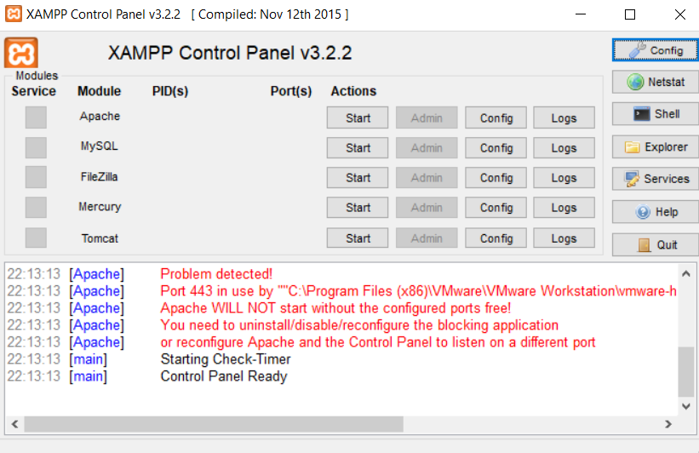
3. Once you click in the start’s option then click in admin option in the MySql Mosdule. 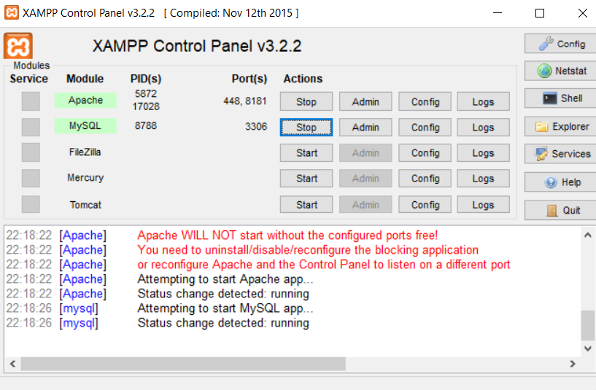
4. Then phpMyAdmin page will open , where the user have create new database in name db_ecommerce and click on the create button.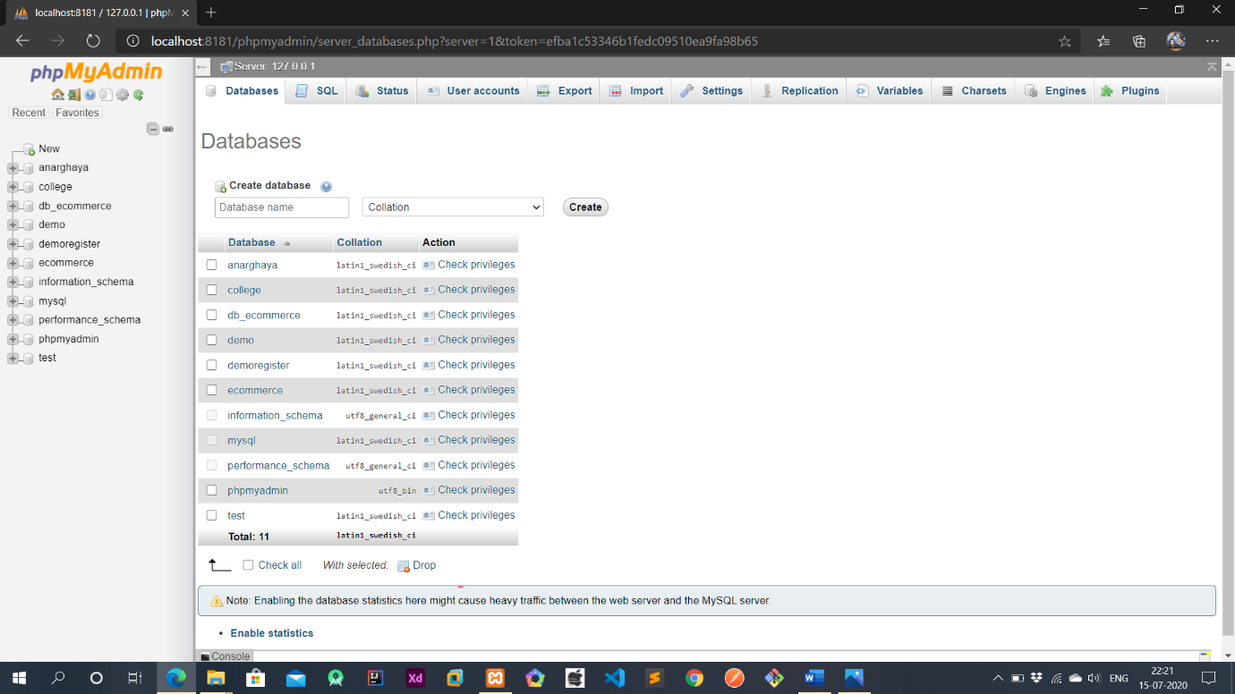
5. Then the database will be create then click the import option , which is present in the top navigation bar. Then this type of page will open where the user have clik on the Choose File Option and then choose the file which is present in the project file. Then click on the Go Button which present in the Last.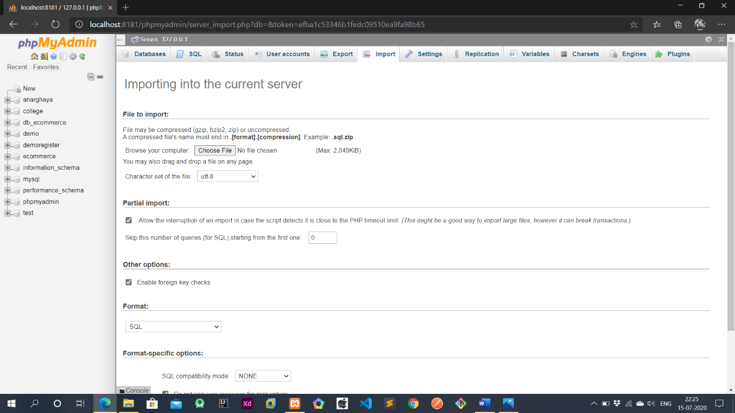
6. Then Open a new Tab in the current browser enter the path of the file to run the project. Then the project will be open in current tab. 

Note : First , please copy the project file from the downloads then paste it in xampp>htdos then only the the project will run.Then in this sample shapshot.

